**What is DNS?**

* Domain Name System which translates the human friendly hostnames into the machine IP addresses
* www.google.com => 172.217.18.36
* DNS is the backbone of the Internet

**DNS Terminologies**

* Domain Registrar: Amazon Route 53, GoDaddy, …
* DNS Records: A, AAAA, CNAME, NS, …
* Zone File: contains DNS records
* Name Server: resolves DNS queries (Authoritative or Non-Authoritative)
* Top Level Domain (TLD): .com, .us, .in, .gov, .org, …
* Second Level Domain (SLD): amazon.com, google.com, …

**How DNS Works**

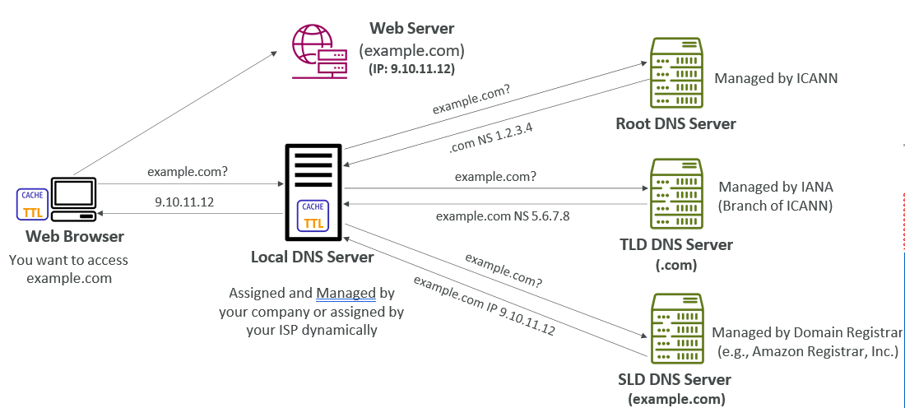

**Amazon Route 53**

* A highly available, scalable, fully managed and Authoritative DNS
* Authoritative = the customer (you) can update the DNS records
* Route 53 is also a Domain Registrar
* Ability to check the health of your resources
* The only AWS service which provides 100% availability SLA
* Why Route 53? 53 is a reference to the traditional DNS port

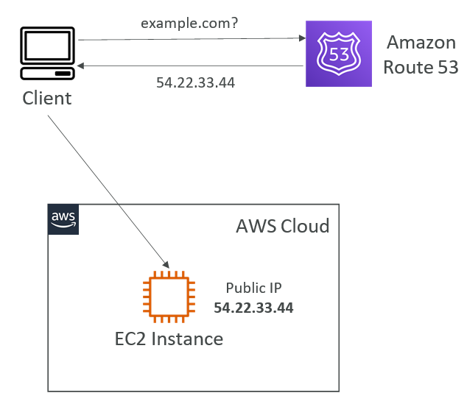

**Route 53 – Records**

* How you want to route traffic for a domain
* Each record contains:
  + Domain/subdomain Name – e.g., example.com
  + Record Type – e.g., A or AAAA
  + Value – e.g., 12.34.56.78
  + Routing Policy – how Route 53 responds to queries
  + TTL – amount of time the record cached at DNS Resolvers
* Route 53 supports the following DNS record types:
  + (must know) A / AAAA / CNAME / NS
  + (advanced) CAA / DS / MX / NAPTR / PTR / SOA / TXT / SPF / SRV

**Route 53 – Record Types**

* A – maps a hostname to IPv4
* AAAA – maps a hostname to IPv6
* CNAME – maps a hostname to another hostname
  + The target is a domain name which must have an A or AAAA record
  + Can’t create a CNAME record for the top node of a DNS namespace (Zone Apex)
  + Example: you can’t create for example.com, but you can create for www.example.com
* NS – Name Servers for the Hosted Zone
  + Control how traffic is routed for a domain

**Route 53 – Hosted Zones**

* A container for records that define how to route traffic to a domain and its subdomains
* Public Hosted Zones – contains records that specify how to route traffic on the Internet (public domain names) application1.mypublicdomain.com
* Private Hosted Zones – contain records that specify how you route traffic within one or more VPCs (private domain names) application1.company.internal
* You pay $0.50 per month per hosted zone

**Route 53 – Public vs. Private Hosted Zones**

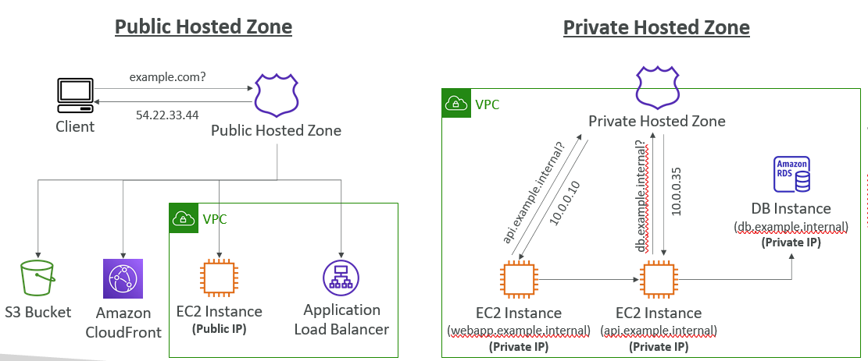

**Route 53 – Records TTL (Time To Live)**

* High TTL – e.g., 24 hr
  + Less traffic on Route 53
  + Possibly outdated records
* Low TTL – e.g., 60 sec.
  + More traffic on Route 53 ($$)
  + Records are outdated for less time
  + Easy to change records
* Except for Alias records,TTL is mandatory for each DNS record

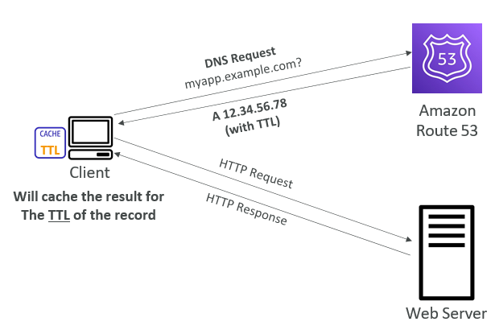

**CNAME vs Alias**

* AWS Resources (Load Balancer, CloudFront...) expose an AWS hostname:
  + lb1-1234.us-east-2.elb.amazonaws.com and you want myapp.mydomain.com
* CNAME:
  + Points a hostname to any other hostname. (app.mydomain.com => blabla.anything.com)
  + ONLY FOR NON ROOT DOMAIN (aka. something.mydomain.com)
* Alias:
  + Points a hostname to an AWS Resource (app.mydomain.com => blabla.amazonaws.com)
  + Works for ROOT DOMAIN and NON ROOT DOMAIN (aka mydomain.com)
  + Free of charge
  + Native health check

**Route 53 – Alias Records**

* Maps a hostname to an AWS resource
* An extension to DNS functionality
* Automatically recognizes changes in the resource’s IP addresses
* Unlike CNAME, it can be used for the top node of a DNS namespace (Zone Apex), e.g.: example.com
* Alias Record is always of type A/AAAA for AWS resources (IPv4 / IPv6)
* You can’t set the TTL

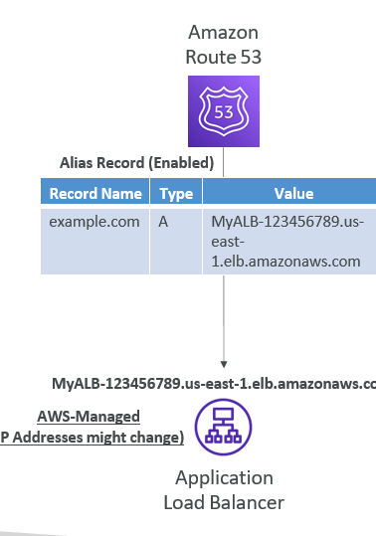

**Route 53 – Alias Records Targets**

* Elastic Load Balancers
* CloudFront Distributions
* API Gateway
* Elastic Beanstalk environments
* S3 Websites
* VPC Interface Endpoints
* Global Accelerator accelerator
* Route 53 record in the same hosted zone
* You cannot set an ALIAS record for an EC2 DNS name

**Route 53 – Routing Policies**

* Define how Route 53 responds to DNS queries
* Don’t get confused by the word “Routing”
  + It’s not the same as Load balancer routing which routes the traffic
  + DNS does not route any traffic, it only responds to the DNS queries
* Route 53 Supports the following Routing Policies
  + Simple
  + Weighted
  + Failover
  + Latency based
  + Geolocation
  + Multi-Value Answer
  + Geoproximity (using Route 53 Traffic Flow feature)

**Routing Policies – Simple**

* Typically, route traffic to a single resource
* Can specify multiple values in the same record
* If multiple values are returned, a
* random one is chosen by the client
* When Alias enabled, specify only one AWS resource
* Can’t be associated with Health Checks

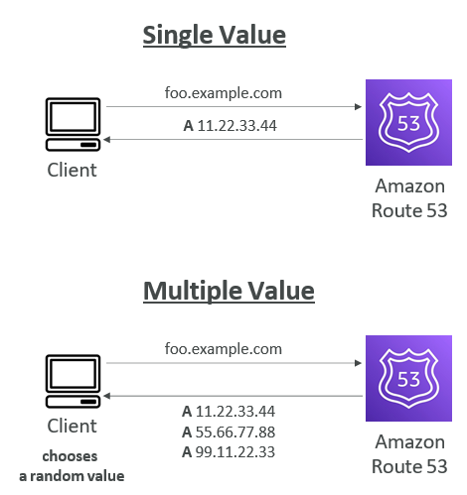

**Routing Policies – Weighted**

* Control the % of the requests that go to each specific resource
* Assign each record a relative weight:
  + 𝑡𝑟𝑎𝑓𝑓𝑖𝑐 (%) = !"#$%& '() * +,"-#'#- )"-().
  + /01 (' *22 &%" 3"#$%&+ '() *22 )"-().+
  + Weights don’t need to sum up to 100
* DNS records must have the same name and type
* Can be associated with Health Checks
* Use cases: load balancing between regions, testing new application versions…
* Assign a weight of 0 to a record to stop sending traffic to a resource
* If all records have weight of 0, then all records will be returned equally

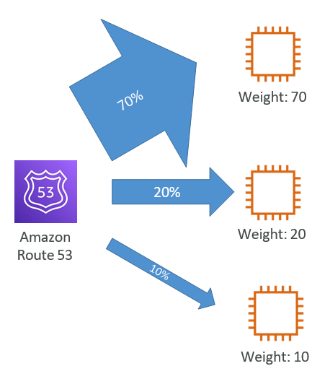

**Routing Policies – Latency-based**

* Redirect to the resource that has the least latency close to us
* Super helpful when latency for users is a priority
* Latency is based on traffic between users and AWS Regions
* Germany users may be directed to the US (if that’s the lowest latency)
* Can be associated with Health Checks (has a failover capability)

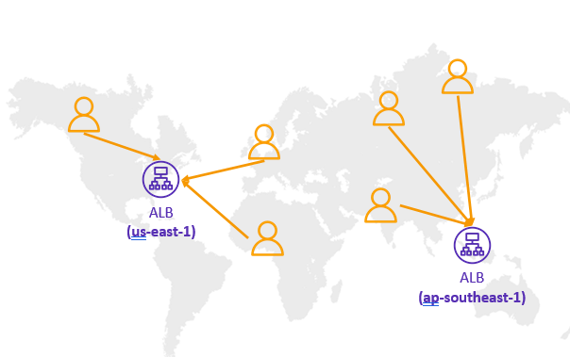

**Route 53 – Health Checks**

* HTTP Health Checks are only for public resources
* Health Check => Automated DNS Failover:
  + Health checks that monitor an endpoint (application, server, other AWS resource)
  + Health checks that monitor other health checks (Calculated Health Checks)
  + Health checks that monitor CloudWatch Alarms (full control !!) – e.g., throttles of DynamoDB, alarms on RDS, custom metrics,

… (helpful for private resources)

* Health Checks are integrated with CW metrics

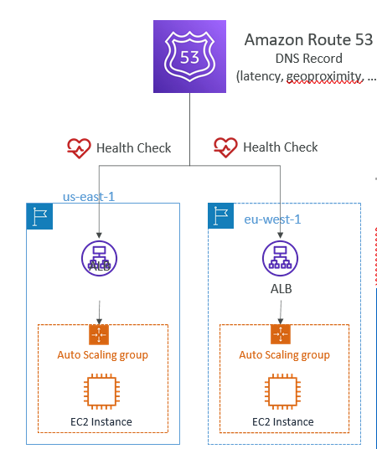

**Health Checks – Monitor an Endpoint**

* About 15 global health checkers will check the endpoint health
  + Healthy/Unhealthy Threshold – 3 (default)
  + Interval – 30 sec (can set to 10 sec – higher cost)
  + Supported protocol: HTTP, HTTPS and TCP
  + If > 18% of health checkers report the endpoint is healthy, Route 53 considers it Healthy. Otherwise, it’s Unhealthy
  + Ability to choose which locations you want Route 53 to use
* Health Checks pass only when the endpoint responds with the 2xx and 3xx status codes
* Health Checks can be setup to pass / fail based on the text in the first 5120 bytes of the response
* Configure you router/firewall to allow incoming requests from Route 53 Health Checkers

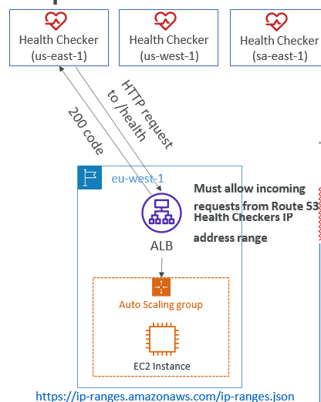

**Route 53 – Calculated Health Checks**

* Combine the results of multiple Health Checks into a single Health Check
* You can use OR, AND, or NOT
* Can monitor up to 256 Child Health Checks
* Specify how many of the health checks need to pass to make the parent pass
* Usage: perform maintenance to your website without causing all health checks to fail

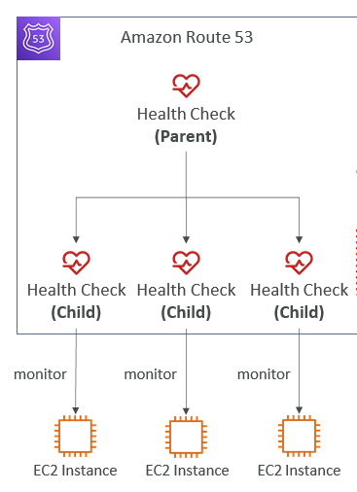

**Health Checks – Private Hosted Zones**

* Route 53 health checkers are outside the VPC
* They can’t access private endpoints (private VPC or on-premises resource)
* You can create a CloudWatch Metric and associate a CloudWatch Alarm, then create a Health Check that checks the alarm itself

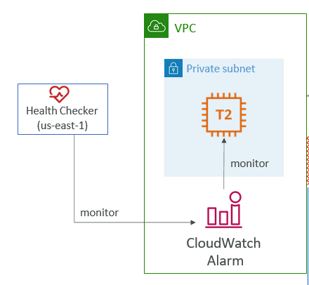

**Routing Policies – Failover (Active-Passive)**

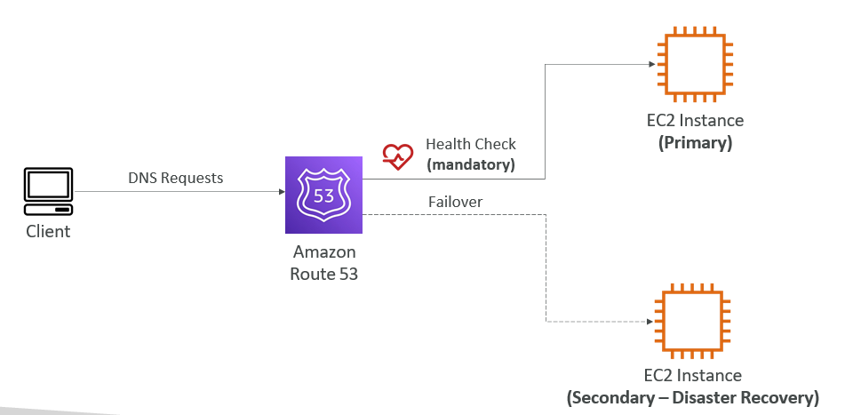

**Routing Policies – Geolocation**

* Different from Latency-based!
* This routing is based on user location
* Specify location by Continent, Country or by US State (if there’s overlapping, most precise location selected)
* Should create a “Default” record (in case there’s no match on location)
* Use cases: website localization, restrict content distribution, load balancing,…
* Can be associated with Health Checks

**Routing Policies – Multi-Value**

* Use when routing traffic to multiple resources
* Route 53 return multiple values/resources
* Can be associated with Health Checks (return only values for healthy resources)
* Up to 8 healthy records are returned for each Multi-Value query
* Multi-Value is not a substitute for having an ELB